ADVENTURE WORKS · TECHNICAL SUPPORT

Suspension Fork Not Working or Setting Sag
Suspension Document TS-018 Rev. A
Applies to | Trailblazer MTB, Summit Trail (suspension models)
Difficulty | Intermediate
Time required | 20 – 40 minutes
Tools needed | Shock pump, Sag measurement (zip tie / o-ring), Hex keys

Symptoms
- The fork feels harsh and barely moves over bumps.
- The fork dives too easily or bottoms out hard.
- Uneven or sticky travel with a 'clunk'.
- Oil weeping from the seals.
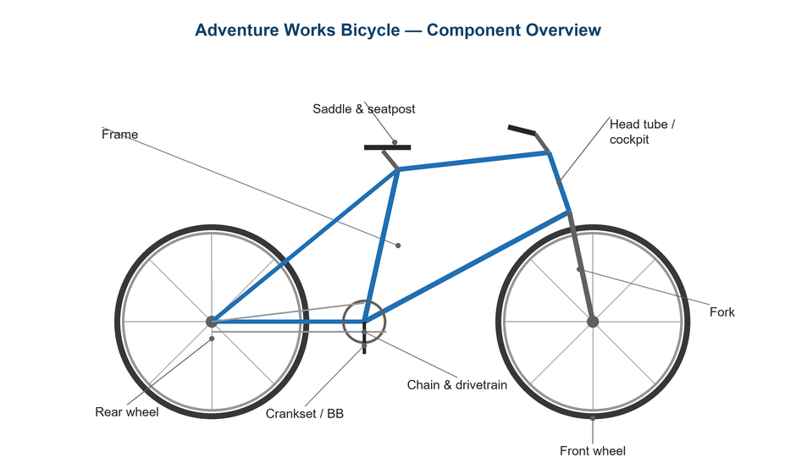
Figure 1. The suspension fork connects the front wheel to the cockpit.

Likely Causes
- Incorrect air pressure for the rider's weight.
- The lockout or compression damping is left fully closed.
- Low air volume or lost pressure over time.
- Dry stanchions/seals needing service.
- Worn seals leaking oil and air.
Safety first
- Use a proper shock pump with a gauge — never a tire pump or compressor on an air fork.
- Release pressure slowly; air forks hold high pressure.
- Don't ride with leaking seals — internal damage can follow.

Customer Fix — Step by Step
Suitable for home repair with basic tools. Work through the steps in order.
- Confirm the lockout/compression lever is fully open before testing the fork's movement.
- Set sag: fit a zip tie or use the o-ring on the stanchion, sit on the bike in riding position, and measure how far it compresses.
- Aim for roughly 15–20% sag for cross-country and 20–30% for trail riding (check your fork's chart).
- Adjust air pressure with a shock pump in small steps to reach the target sag — more pressure for less sag.
- Set rebound so the fork returns quickly but doesn't 'pogo'.
- Wipe the stanchions clean and add a drop of suspension oil to keep seals supple.

Technician Reference
Additional checks and adjustments for service technicians and advanced users.
- Perform a lower-leg service: clean, inspect, and re-oil the seals and foam rings at the maker's interval.
- Check air-spring pressure holds over 24 hours; a drop indicates a failing seal or valve.
- Inspect stanchions for scratches that damage seals; replace seals if oil is weeping.
- Verify token/volume-spacer count to tune bottom-out resistance.
- Set compression and rebound from the maker's baseline for rider weight, then fine-tune on terrain.

Torque & Specifications
Setting | Guidance
XC sag | 15 – 20% of travel
Trail sag | 20 – 30% of travel
Air tool | Shock pump only
Lower-leg service | Every 50 hrs (typical)
Pressure check | Hold over 24 hrs

Figure 2. Set sag with the rider in normal riding position, then tune rebound.
Pro tips
- Note your air pressure and clicks once dialed in so you can reset after travel.
- A quick stanchion wipe before each ride dramatically extends seal life.

When to Visit a Service Center
- Seals are leaking oil or the fork loses pressure quickly.
- Internal damping needs a full service or rebuild.
- Stanchions are scratched or pitted.
- The fork still feels harsh or uneven after sag and rebound setup.
This guide is provided for reference. Torque values are typical starting points — always follow the specific component manufacturer's instructions. © Adventure Works.

